First, we need to get data from Azure Blob storage.

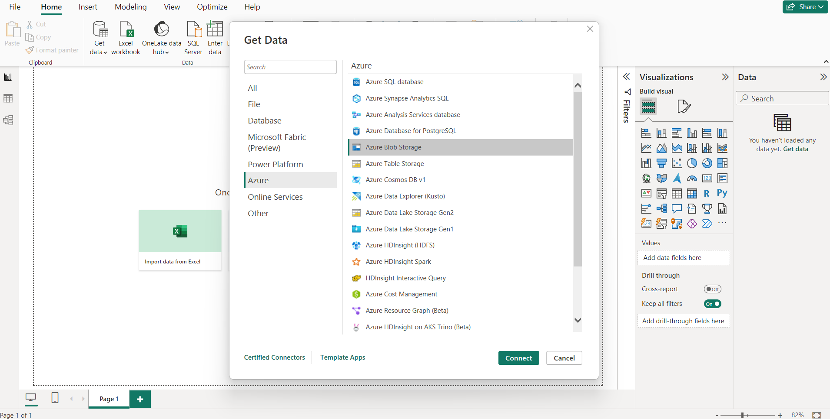

After selecting the Data Storage Location, we get a prompt to enter our credentials. Then we get the navigator pane to pick and choose the required folder.

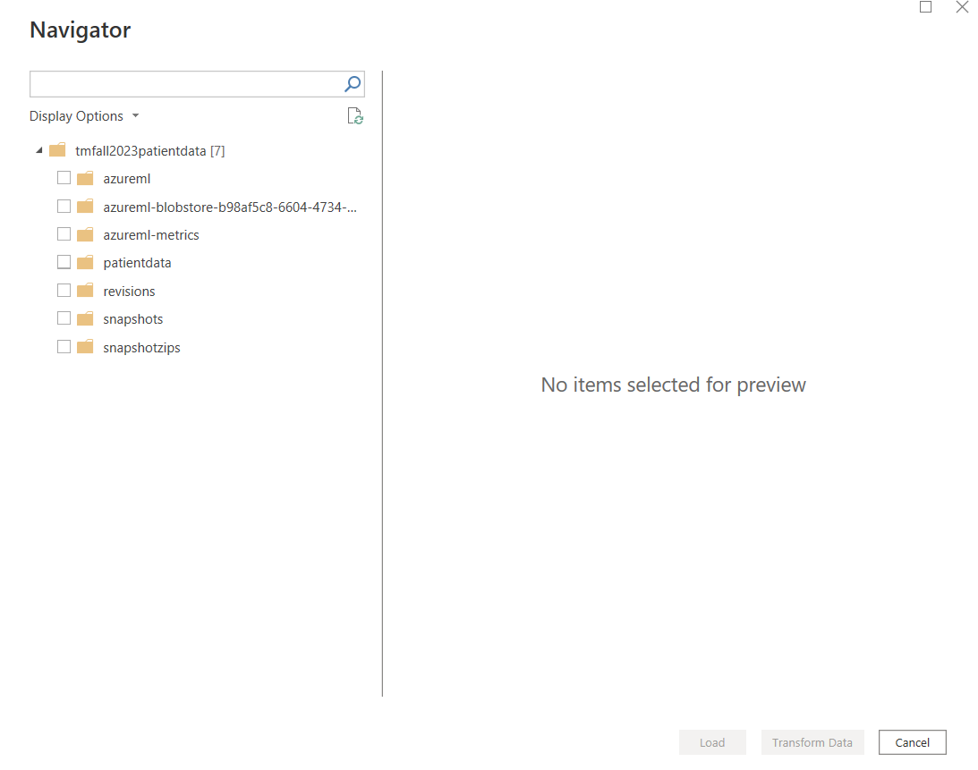

Then, we perform transformation to make our data usable for PowerBi.

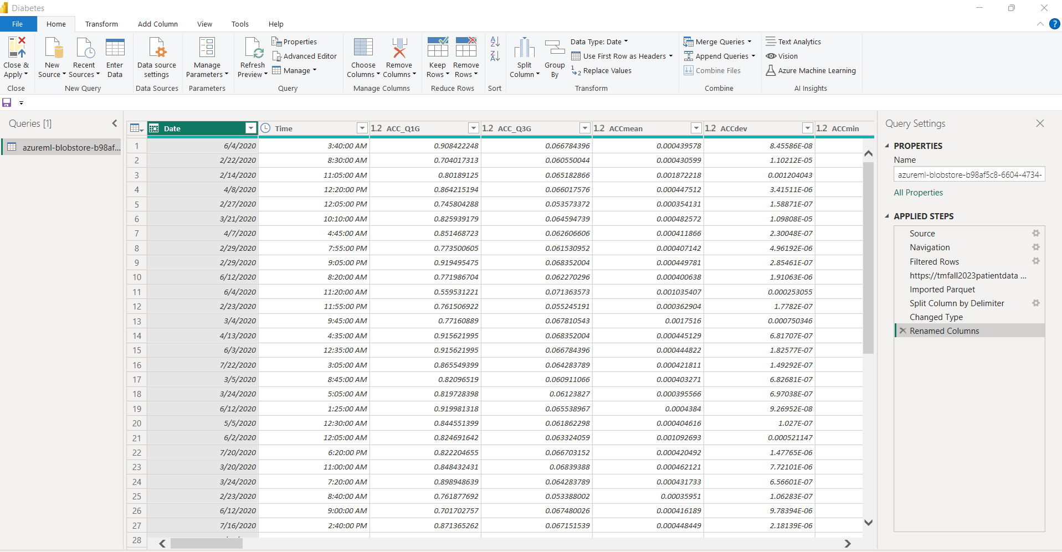

Then, we built visuals for the Actual and Predicted Glucose readings with respect to days and having Patient ID as a filter which, we can change according to our preference.



